Ankita Durgude

SQL Exercise 1

1. **Create the table SEMP with the following structure:- EMPNO CHAR(4)**

**EMPNAME CHAR(20) BASIC FLOAT**

**DEPTNO CHAR(2) DEPTHEAD CHAR(4)**

Ans

create table SEMP(

-> EMPNO CHAR(4),

-> EMPNAME CHAR(20),

-> BASIC FLOAT,

-> DEPTNO CHAR(2),

-> DEPTHEAD CHAR(4));

1. **Create the table SDEPT with the following structure:- DEPTNO CHAR(2)**

**DEPTNAME CHAR(15)**

Ans

create table SDEPT(

-> DEPTNO CHAR(2),

-> DEPTNAME CHAR(15));

1. **Insert into the SDEPT table the following values:- 10, Development**

20, Training

**Ans:** insert into SDEPT values

-> (10, 'Development'),

-> (20, 'Training');

1. **Insert into the SEMP table the following values:- 0001, SUNIL, 6000, 10**

**0002, HIREN, 8000, 20**

**0003, ALI, 4000, 10, 0001**

**0004, GEORGE, 6000, 0002**

Ans:

insert into SEMP values

-> (0001, 'SUNIL', 6000, 10,null),

-> (0002, 'HIREN', 8000, 20,null),

-> (0003, 'ALI', 4000, 10, 0001),

-> (0004, 'GEORGE', 6000,null, 0002);

Create S, P, J, SPJ tables as specified below and insert a few rows in each table:-

**SUPPLIER**

(S#, Sname, Status, City) - S PARTS

(P#, Pname, Color, Weight, City) - P PROJECTS

(J#, Jname, City) - J

SUPPLIER-PARTS-PROJECT (S#, P#, J#, Qty)

**- SPJ**

Sample data for S# column:- ‘S1’, ‘S2’, ‘S3’, etc. Sample data for P# column:- ‘P1’, ‘P2’, ‘P3’, etc. Sample data for J# column:- ‘J1’, ‘J2’, ‘J3’, etc.

Sample data for Status column:- 10, 20, 30, etc.

Write the SELECT queries to do the following:-

1. 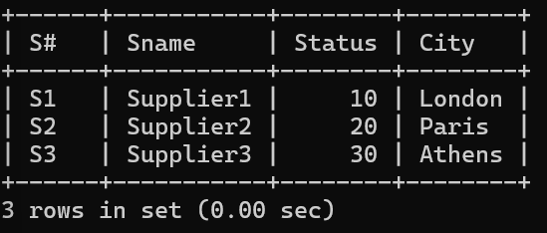**Display all the data from the S table. Ans:** Select* from SUPPLIER;
2. **Display only the S# and SNAME fields from the S table. Ans:** select `S#`,SNAME from SUPPLIER;

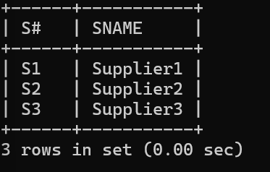

1. 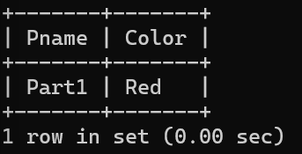**Display the PNAME and COLOR from the P table for the CITY=”London”. Ans:** SELECT Pname, Color FROM PARTS WHERE City = 'London';
2. **Display all the Suppliers from London. Ans:** select* Suppliers where City = 'London';

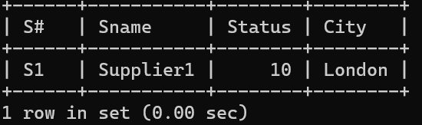

1. **Display all the Suppliers from Paris or Athens.**

**Ans:** select * from Supplier where City in ('Paris','Athens');

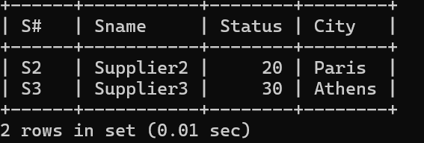

1. **Display all the Projects in Athens.**

**Ans:** select * from PROJECTS where City='Athens';

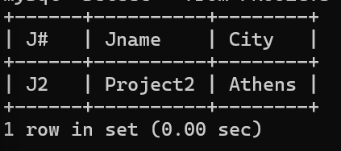

1. **Display all the Partnames with the weight between 12 and 14 (inclusive of both). Ans:** select Pname from Parts where Weight between 12 and 14;

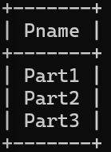

1. **Display all the Suppliers with a Status greater than or equal to 20. Ans:** select * from SUPPLIER where Status >= 20;

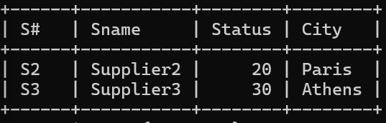

1. **Display all the Suppliers except the Suppliers from London. Ans:** select * from SUPPLIER where City <> 'London';

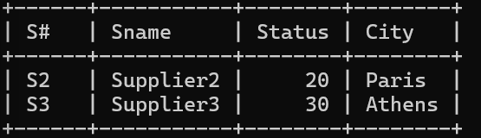

1. **Display only the Cities from where the Suppliers come from. Ans:** Select City from SUPPLIER;

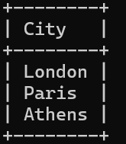

1. **Assuming that the Part Weight is in GRAMS, display the same in MILLIGRAMS and KILOGRAMS.**

**Ans:** select Pname, Weight*1000 as MILLIGRAMS, Weight/1000 as KILOGRAMS from PARTS;

